

Requirement & Design Specification
Global Access Management System (GAMS)
Version: 1.0

– DaNang, May 2026 –

Record of Changes
Version | Date | A*  M, D | In charge | Change Description
V1.0 | 21/5 | A | All Members | Add Actor, Complete Use Case Diagram
V1.0 | 22/5 | A | All Members | Complete Feature descriptions
V1.0 | 27/5 | A | All Members | Complete Overall Functionalities
V1.0 | 29/5 | A | All Members | Complete Database Design
V1.0 | 1/6 | A | All Members | Complete Requirement Specifications
V1.0 | 5/6 | A | All Members | Complete Code Packages
V1.0 | 7/6 | A | Hoàng | Add Code Designs: View Bookings, View Statistic
V1.0 | 10/6 | A | Uyên | Add Code Designs: View Account Lists, Cancle Booking
V1.0 | 13/6 | A | Uyên | Add Code Designs: View Promotions, Add Promotions, Delete Promotion
V1.0 | 15/6 | A | Tùng | Add Code Designs: View Feedback, Delete Feedback
V1.0 | 18/6 | A | Hoàng | Add Code Designs: Book Cars, Change Password, View booking history
V1.0 | 20/6 | A | Nguyên | Add Code Designs: Chat With Customer, Chat With Owner
V1.0 | 22/6 | A | Quang | Add Code Designs: Add Favorite Cars, View Favorite Cars
V1.0 | 24/6 | A | Hoàng | Add Code Designs: Payment, Apply Discount
V1.0 | 27/6 | A | All members | Complete Assumptions & Dependencies
V1.0 | 30/6 | A | All members | Complete Limitations & Exclusions
V1.0 | 2/7 | A | All members | Compler Business Rules
*A - Added M - Modified D - Deleted

Contents
Record of Changes 2
I. Overview 4
1. User Requirements 4
1.1 Actors 4
1.2 Use Cases 4
2. Overall Functionalities 5
2.1 Screens Flow 5
2.2 Screen Descriptions 5
2.3 Screen Authorization 5
2.4 Non-UI Functions 6
3. System High Level Design 6
3.1 Database Design 6
3.2 Code Packages 7
II. Requirement Specifications 8
1. <<Feature Name>> 8
1.1 <<UseCaseCode_UC Name>> 8
2. Common Functions 11
2.1 UC-2_Login System 11
3. Patron Feature 12
3.1 UC-5_Order a Meal 12
3.2 UC-6_Register for Payroll Deduction 13
III. Design Specifications 14
1. <<Feature Name>> 14
1.1 <<SubFeature Name>> 14
1.2 System Access 15
IV. Appendix 19
1. Assumptions & Dependencies 19
2. Limitations & Exclusions 19
3. Business Rules 19
4. .. 19

I. Overview

1. User Requirements

1.1 Actors
# | Actor | Description
1 | Admin | Manages the entire system including users, vehicles, reports, and platform settings. Admin is a specialized role of Customer.
2 | Guest | Unregistered user who can browse the website, search motorbikes, and view vehicle information without logging in.
3 | Customer | Registered user who can book motorbikes, make payments, manage bookings, and submit reviews.
4 | Owner | Manages rental shop information, motorbike inventory, pricing, and rental operations. Owner is a specialized role of Customer.
5 | Staff | Supports daily rental activities such as confirming bookings, checking vehicle conditions, and handling returns. Staff is a specialized role of Customer.

1.2 Use Cases

a. Diagram(s)
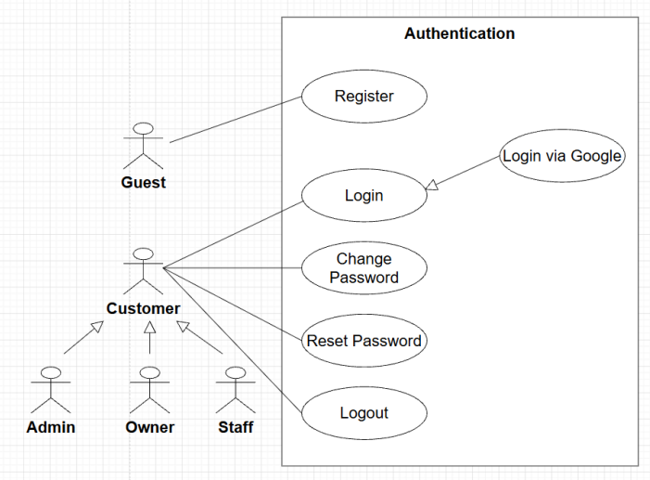
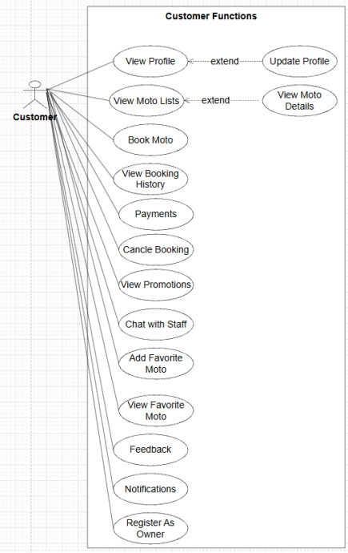
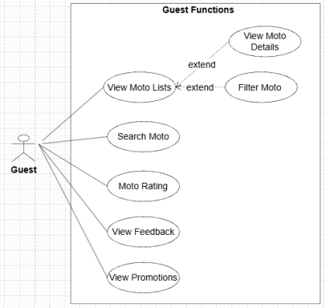
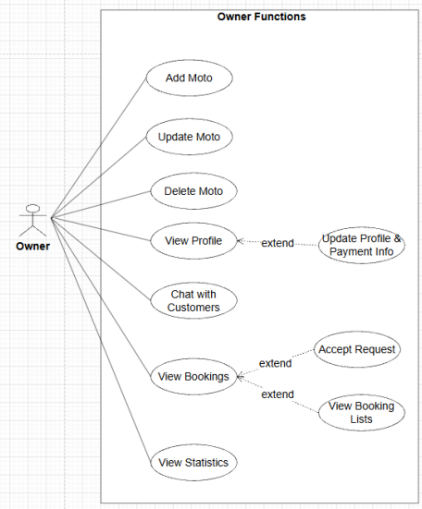
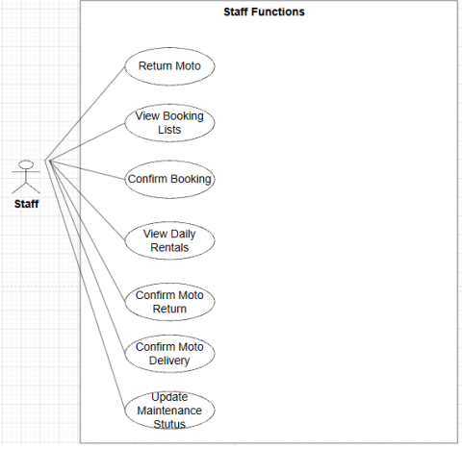
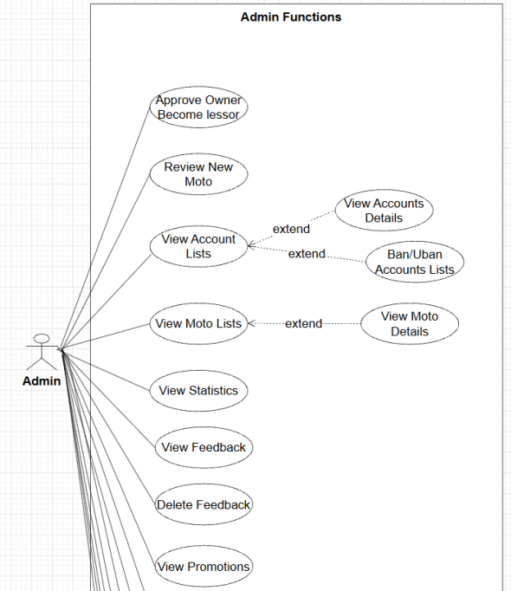
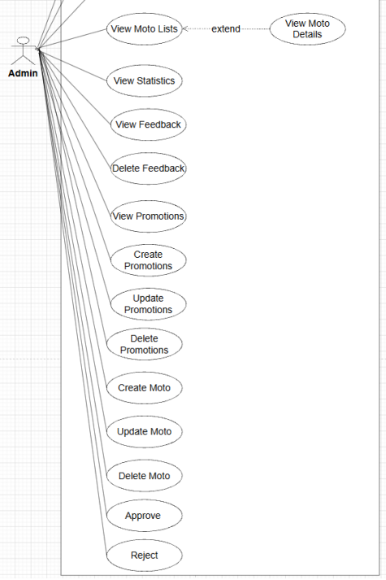

b. Descriptions
ID | Feature | Use Case | Use Case Description
01 | Authentication | Register | Allows a Guest to register a new account on the system.
02 | Authentication | Login | Permits authenticated users (Customer, Admin, Staff) to log in to access protected areas.
03 | Authentication | Login via Google | Allows Customers to authenticate quickly using Google Single Sign-On (SSO).
04 | Authentication | Logout | Terminates the current active user session securely.
05 | Authentication | Reset AuthenticationPassword | Enables users to request a password recovery option if they forget their password.
06 | Authentication | Change Password | Allows logged-in users to update their current password to keep accounts secure.
07 | Authentication | Profile View | Allows users to view their registered personal profile information.
08 | Authentication | Update Profile | Allows users to modify and update their personal profile details.
09 | Motorbike Catalog | Motorbike List | Allows Guests and Customers to browse the comprehensive collection of motorbikes.
10 | Motorbike Catalog | Motorbike Detail | Displays explicit technical specifications, pricing, and specific details of a chosen motorbike.
11 | Motorbike Catalog | Search Motorbike | Provides text search tools to let users find motorbikes by typing keywords.
12 | Motorbike Catalog | Filter Motorbike | Enables filtering options to narrow down vehicles based on criteria (e.g., brand, type, engine capacity).
13 | Motorbike Catalog | Sort Motorbike | Allows sorting of the motorbike list by price, popularity, or rating.
14 | Motorbike Catalog | Related Motorbikes | Displays recommendations of alternative, similar motorbikes when viewing a vehicle.
15 | Motorbike Catalog | Motorbike Rating | Displays aggregate performance scores and ratings from previous customers.
16 | Motorbike Catalog | Motorbike Review | Allows Customers to write text reviews and post feedback on vehicles they have used.
17 | Motorbike Catalog | Favorite Motorbikes | Enables Customers to bookmark and save specific motorbikes into a personal wishlist.
18 | Booking | Create Booking | Enables a Customer to select dates, choose an available vehicle, and submit a rental request.
19 | Booking | Check Availability | Automatically verifies if a specific motorbike is free for the selected date range.
20 | Booking | Rental Conflict Validation | System background logic that enforces schedules and prevents overlapping bookings for the same vehicle.
21 | Booking | Rental Price Calculation | System background logic that aggregates daily vehicle rates to compute the exact rental contract total fee.
22 | Booking | Booking List | Allows a Customer to view a summary list of all their historical and active rental bookings.
23 | Booking | Booking Detail | Displays the granular breakdown and configuration of an explicit booking order.
24 | Booking | Cancel Booking | Enables a Customer to request the termination of a future booking request.
25 | Booking | Booking Tracking | Allows real-time operational state tracking of a active booking lifecycle.
26 | Booking | Return Motorbike | Allows Staff to process incoming returned vehicles at the physical shop
27 | Booking | Late Return Fee | System background logic that computes overdue penalty prices if a bike is returned past the deadline.
28 | Payment | Cash Payment | Handles Cash on Delivery (COD) configuration where payment occurs at physical pickup.
29 | Payment | Online Payment | Routes the customer transaction request securely through an online electronic payment gateway.
30 | Payment | Payment History | Provides a readable transactional log of past financial payments made by the Customer.
31 | Verification | Upload Citizen ID | Allows Customers to upload images of their identity cards/CCCD for administrative compliance.
32 | Verification | Verify Customer Identity | Allows Admins to inspect uploaded credentials and transition customer authorization states.
33 | Notification | Booking Confirmation | Triggers an immediate notification/email confirmation text once a booking request is accepted.
34 | Notification | Booking Reminder | Automated system utility that triggers alerts to customers before their rental contract begins or ends.
35 | Notification | System Notification | Dispatches contextual, live in-app notifications directly to targeted users (Customer, Staff, Admin).
36 | Staff Management | View Booking List | Provides a unified management view of incoming rental booking requests for Staff review.
37 | Staff Management | Confirm Booking | Allows Staff to authorize and officially accept incoming pending customer bookings.
38 | Staff Management | Confirm Bike Pickup | Logs a verification stamp when a customer physically arrives and picks up the vehicle.
39 | Staff Management | Confirm COD Payment | Allows Staff to log and verify cash handovers collected during physical vehicle pick-ups.
40 | Staff Management | Update Motorbike Status | Allows Staff to change immediate vehicle statuses (e.g., Available, Rented, Maintenance).
41 | Staff Management | View Daily Rentals | Displays a dynamic scheduling calendar displaying daily operational pickups and handovers.
42 | Admin | Create Motorbike | Allows Admin to provision and add an entirely new vehicle asset record to the fleet inventory.
43 | Admin | Update Motorbike | Allows Admin to change information or metadata on existing vehicle profiles.
44 | Admin | Delete Motorbike | Allows Admin to archive or remove a vehicle record from active listings.
45 | Admin | Motorbike Category CRUD | Full Create, Read, Update, and Delete control over motorbike categorical classifications and tags.
46 | Admin | Inventory Update | Allows Admin to audit, adjust, and update global inventory records.
47 | Admin | Low Availability Alert | Automatic warning trigger flags on the Admin view when available fleets fall below a threshold.
48 | Admin | Booking Management | Grants comprehensive master control to audit, overwrite, or intervene in any booking on the system.
49 | Admin | User Management | Full administrative power to create, update, suspend, or manage roles of any account database row.
50 | Admin | Review Motorbikes | Allows Admin to approve newly listed vehicles before they go live on public menus.
51 | Admin | Delete Feedback | Moderation tool allowing Admin to purge malicious, inappropriate, or spam customer reviews.
52 | Admin | Promotion Management | System tool for managing marketing coupon codes, campaigns, and rental discounts.
53 | Admin | Dashboard | Central portal summary presenting visual metric charts and real-time operational summaries.
54 | Admin | Analytics | Generates advanced business intelligence reports covering system performance indicators.
55 | Admin | Top Rented Motorbikes | Displays system reporting on high-performing, frequently rented motorbike units.
56 | Support | Contact Staff | Provides communication support channels for Customers to request human staff assistance.
57 | Support | Report User | Allows Customers to flag fraudulent activities or report malicious platform profiles.

2. Overall Functionalities

2.1 Screens Flow
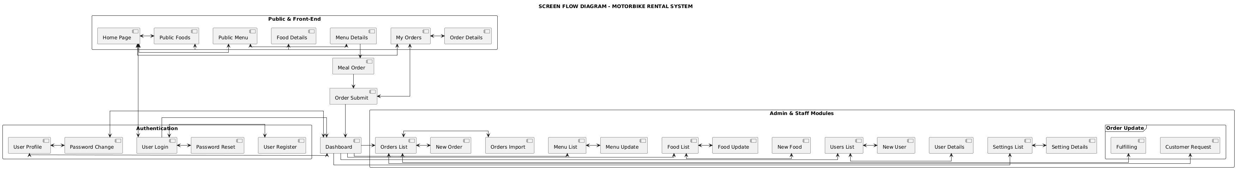

2.2 Screen Descriptions

# | Feature | Screen | Description
1 | Common / Auth | Login & Registration Screen | Form fields for email/password authentication, password recovery triggers, and single-click integration hooks for Google OAuth SSO.
2 | Motorbike Catalog | Motorbike Catalog Portal | A primary grid layout displaying available fleet vehicles. Integrates text search boxes, multi-attribute filter widgets (brand, category), and sorting dropdowns.
3 | Motorbike Catalog | Motorbike Details View | Displays granular specifications of a chosen vehicle, customer aggregate scores/reviews, dynamic related bike carousel recommendations, and action toggles to add to wishlists or initiate booking.
4 | Booking / Verification | Booking Checkout Desk | A multi-step form workflow where customers select dates, verify vehicle availability, upload a Citizen ID file attachment (.png/.jpg, max 5MB), and select the payment type.
5 | Booking | Customer Booking List | A personalized dashboard for customers to review their rental histories, track active booking lifecycle stages (Pending, Confirmed, Picked Up, Completed), or trigger cancellations.
6 | Staff Management | Daily Rental Board | A spreadsheet-style operational desk enabling Staff to monitor daily pickup/return schedules, input cash handovers, and change bike statuses.
7 | Admin Management | Admin Analytics Dashboard | An executive control panel rendering real-time KPI data charts, automated low availability alerts, and data tables for user accounts, promotions, and fleet inventory management.

2.3 Screen Authorization

Screen / Functional Action | Guest | Customer | Staff | Admin
Browse Catalog, Search & Filter Motorbikes | X | X | X | X
View Motorbike Ratings & Reviews | X | X | X | X
Submit Reviews & Manage Favorites Wishlist |  | X
Create Booking & Upload Citizen ID |  | X
Track Personal Booking List & Payment History |  | X
View Booking Requests & Daily Rental Calendars |  |  | X | X
Confirm Pickups, Returns, & COD Cash Payments |  |  | X | X
Update Immediate Motorbike Status Codes |  |  | X | X
Motorbike CRUD & Category Management |  |  |  | X
Approve New Bikes, Manage Users, & Verify IDs |  |  |  | X
Delete Inappropriate Feedback & Manage Promotions |  |  |  | X
Access Executive Dashboard & Analytics Reports |  |  |  | X

2.4 Non-UI Functions
# | Feature | System Function | Description
1 | Booking | Rental Conflict Validator | A real-time database indexing service running execution queries to intercept and block overlapping rental timelines for the same vehicle ID.
2 | Booking | Late Return Fee Processor | A scheduled background worker that evaluates overdue return hour gaps and automatically appends penalty charges according to system formulas.
3 | Booking | Automated Booking Reminder Driver | A background cron job that periodically polls reservation schedules and triggers email/SMS alerts to customers before their contract starts or ends.
4 | Notification | Live In-App Notification Pusher | A persistent WebSocket worker thread that instantly dispatches contextual alerts regarding booking confirmations and administrative alerts to active client screens.
5 | Admin | Low Availability Alert Sentinel | A continuous inventory counter service that flashes critical warning flags on the Admin dashboard when specific vehicle model volumes drop below safe thresholds.

3. System High Level Design

3.1 Database Design
[Provide the tables relationship like example below]

a. Database Schema
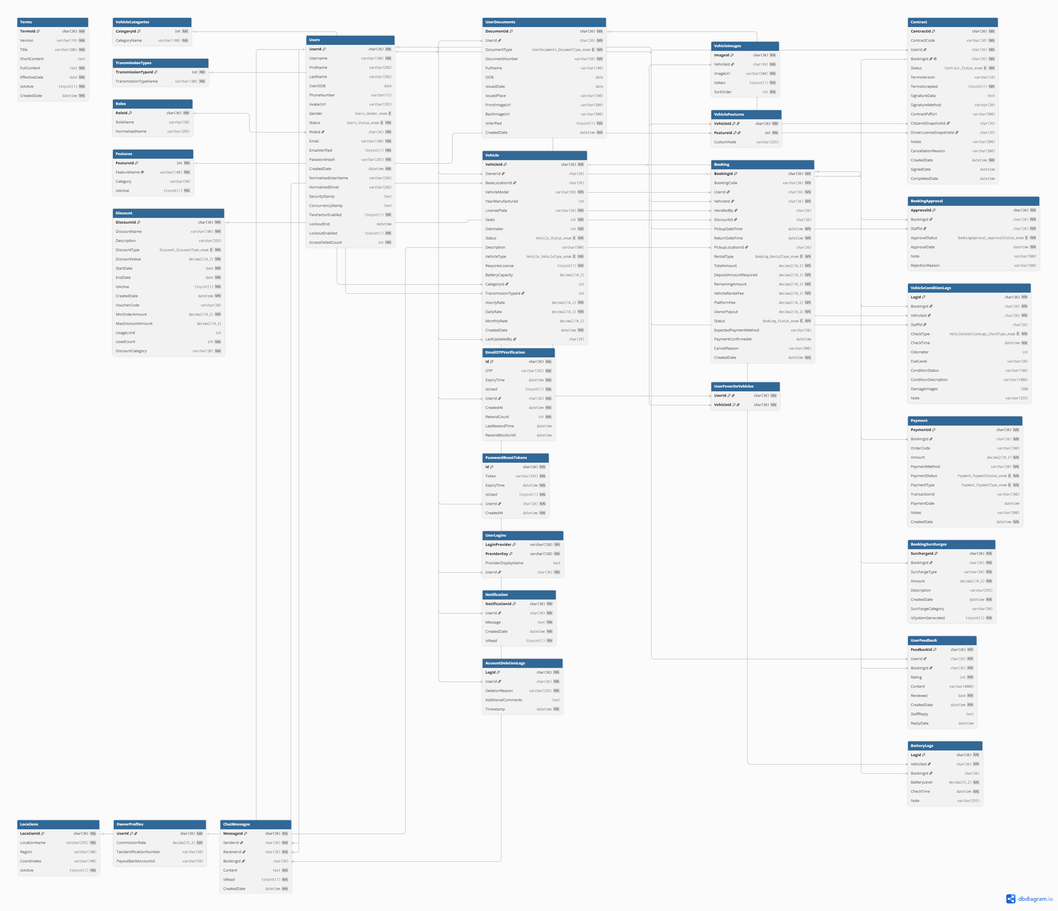

b. Table Descriptions
No | Table | Description
01 | Users | Stores identity, authentication, profile, and security status for all system users (including customers and vehicle owners).  - Primary keys: UserID  - Foreign keys: None
02 | UserDocuments | Manages legal verification documents uploaded by users, such as National IDs, passports, or driver's licenses.  - Primary keys: DocumentID  - Foreign keys: UserID (references Users)
03 | Vehicle | Contains detailed specifications, ownership, pricing, and current availability status of vehicles listed on the platform.  - Primary keys: VehicleID  - Foreign keys: OwnerID (references Users), CategoryID (references VehicleCategories), TransmissionTypeID (references TransmissionTypes)
04 | VehicleCategories | Classifies vehicles into distinct structural types (e.g., Sedan, SUV, Hatchback, Truck) for filtering and pricing strategies.  - Primary keys: CategoryID  - Foreign keys: None
05 | TransmissionTypes | Defines the operational transmission systems of the vehicles (e.g., Manual, Automatic).  - Primary keys: TransmissionTypeID  - Foreign keys: None
06 | VehicleImages | Stores media assets and image paths linked to listed vehicles for marketplace display.  - Primary keys: ImageID  - Foreign keys: VehicleID (references Vehicle)
07 | VehicleFeatures | Maps specific features and onboard amenities (e.g., GPS, Sunroof, Dashcam, Bluetooth) to vehicles.  - Primary keys: FeatureID, VehicleID  - Foreign keys: VehicleID (references Vehicle)
08 | Booking | Captures the core transactional lifecycle of a vehicle rental reservation, including rental durations, base costs, and order statuses.  - Primary keys: BookingID  - Foreign keys: CustomerID (references Users), VehicleID (references Vehicle), DiscountID (references Discount)
09 | BookingApproval | Records the audit log and approval state workflow executed by owners or system administrators for pending bookings.  - Primary keys: ApprovalID  - Foreign keys: BookingID (references Booking), ApproverID (references Users)
10 | Contract | Manages digital legal agreements and e-contracts generated between renters and the platform/owners upon booking confirmation.  - Primary keys: ContractID  - Foreign keys: BookingID (references Booking)
11 | Payment | Logs financial transaction details, billing metrics, and payment gate statuses for deposits and rental charges.  - Primary keys: PaymentID  - Foreign keys: BookingID (references Booking)
12 | VehicleConditionLogs | Tracks the physical state of the vehicle (fuel levels, odometer readings, scratches, damages) during pick-up and drop-off checklists.  - Primary keys: LogID  - Foreign keys: BookingID (references Booking), VehicleID (references Vehicle)
13 | BookingSurcharges | Handles automated or manual post-rental penalties and incidental fees (e.g., late returns, refueling shortages, cleaning fees).  - Primary keys: SurchargeID  - Foreign keys: BookingID (references Booking)
14 | Discount | Manages promotional campaign logic, coupon rules, and voucher parameters applied to lower booking prices.  - Primary keys: DiscountID  - Foreign keys: None
15 | UserFeedback | Stores ratings and review descriptions left by renters regarding vehicle condition and service quality post-trip.  - Primary keys: FeedbackID  - Foreign keys: BookingID (references Booking), UserID (references Users)
16 | Notification | Acts as an inbox queue storing push messages, transactional alerts, and system notifications dispatched to users.  - Primary keys: NotificationID  - Foreign keys: UserID (references Users)
17 | TwoFactorVerification | Manages short-lived secure One-Time Passwords (OTP) and timestamps supporting Two-Factor Authentication (2FA).  - Primary keys: ID  - Foreign keys: UserID (references Users)
18 | UserLogins | Tracks federated authentication tokens, external login providers, and historical security log sessions.  - Primary keys: LoginProvider, ProviderKey  - Foreign keys: UserID (references Users)

3.2 Code Packages
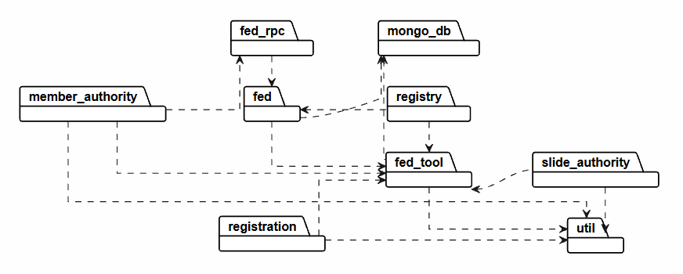
Package descriptions
No | Package | Description
01 | member_authority | Functional Role: Handles user identity classification, authorization controls (Admin, Staff, Customer, Owner), and access token validations.  Data Integration: Executes read/write operations on the MongoDB Users Collection. It validates credentials, session states, and security claims by accessing field states such as twoFactorEnabled, role, and the embedded sub-document array UserLogins.
02 | registration | Functional Role: Coordinates the onboarding workflow for guests registering as Renters or vehicle Owners, alongside managing account activation cycles.  Data Integration: Checks for field uniqueness constraints regarding user email and phone numbers before executing document insertions into the MongoDB Users Collection. It also transiently verifies account status changes via One-Time Password (OTP) records.
03 | fed_rpc | Functional Role: Serves as the Remote Procedure Call (RPC) gateway interface for incoming remote request handling.  Data Integration: Encapsulates API requests, serializes execution payloads, and handles parameters regarding incoming booking timelines from client applications before delegating the control flow downwards to lower-level services.
04 | fed | Functional Role: Functions as the primary core business logic engine and central front-end dispatching orchestrator for the entire application.  Data Integration: Moderates the core rental transactional workflows mapped to the MongoDB Booking Collection. It validates voucher structures extracted from the MongoDB Discount Collection and ensures collision-free vehicle booking schedules.
05 | mongo_db | Functional Role: Operates as the foundational data management persistence layer for the underlying NoSQL cluster.  Data Integration: Explicitly manages database server routing clients, maintains BSON object-mapping formatting configurations, and coordinates query optimizations across all 18 primary database collections (including Vehicle, Booking, Contract, Payment).
06 | fed_tool | Functional Role: Delivers low-level operational algorithmic libraries and computation-heavy utility scripts.  Data Integration: Computes cryptographic routines for password protection, translates physical image array manipulations, and calculates electric vehicle metric thresholds such as state-of-charge tracking arrays located inside the MongoDB BatteryLogs.
07 | util | Functional Role: Encapsulates system-wide software configurations, structural global constants, and standard payload adapters.  Data Integration: Hosts the default Jackson ObjectMapper profile to effortlessly translate Java objects to native NoSQL BSON models, sets standard timezone variables, and defines strict API system-level Error Codes.
08 | registry | Functional Role: Manages vehicle hub physical allocations, geographical zones, and station identification procedures.  Data Integration: Leverages structural GeoJSON geospatial modeling combined with database-level 2dsphere indexes on the MongoDB Locations Collection to pinpoint coordinate arrays for vehicle pick-up and drop-off hubs.
09 | slide_authority | Functional Role: Separates isolated supervisory review workflows and credentials verification auditing pipelines.  Data Integration: Oversees the verification pipelines for eKYC identification objects (National ID, Driving Licenses) hosted within the MongoDB UserDocument Collection and logs physical vehicle handover damage records inside MongoDB VehicleConditionLogs.

II. Requirement Specifications

1. Authentication Feature

1.1 UC-01: Login System (Đăng nhập hệ thống)

a. Functionalities
Functional Description Template
UC ID and Name: | UC-01: Login
Created By: | Bao Uyen | Date Created: | 27/5/2026
Primary Actor: | Customer | Secondary Actors: | Staff, Admin
Trigger: | The user clicks on the "Login" button on the navigation bar or is automatically prompted to log in when trying to access a protected feature (e.g., booking a bike or adding a vehicle to favorites).
Description: | Allows registered users to authenticate into the application using their standard system credentials (Email and Password) or via Google Single Sign-On (SSO) to access role-specific system capabilities.
Preconditions: | - The user must have a registered account existing in the system database.  2. The user's account must not be currently locked or suspended.
Postconditions: | - A secure active session token (JWT) is generated for the authenticated user.  - The user is successfully redirected to their designated system role dashboard.  3. The failed login attempt counter for the account is reset to zero.
Normal Flow: | - The system displays the Authentication form containing input fields for Email and Password, a "Login" action button, and a "Login via Google" button.  - The user inputs their registered Email and Password into the corresponding fields and clicks the "Login" button.  - The system captures the inputs, hashes the plaintext password string, and queries the database to match credentials.  - The system validates that the credentials match and that the account status is active.  - The system generates a secure authentication session token (JWT).  - The system identifies the user's role and redirects them to their designated entry dashboard (Customer Catalog, Staff Operational Board, or Admin Dashboard).
Alternative Flows: | 2a. Login via Google SSO:  - At step 2, the user clicks the "Login via Google" button.  - The system initiates an authentication request and routes the user to the secure Google OAuth 2.0 API gateway page.  - The user selects and confirms their Google account identity.  - Google returns a secure validation token to the system.  - The system intercepts the token and validates the email address:  - If the Google email does not exist in the database, the system automatically registers a new account with the role of Customer and lands them on the Catalog.  - If the email already exists, the system directly initializes the user session and routes them to their landing dashboard.
Exceptions: | 3a. Invalid Authentication Credentials:  - The system detects that the email address does not exist or the password hash does not match the database record.  - The system increments the failed login attempt counter for that specific account.  - The system rejects the entry, clears the password field, and displays an error message: "Invalid Email or Password. Please try again."
Priority: | High (Medium, Low), Must Have (Should Have, Could Have),..
Frequency of Use: | Extremely High (Executed every time an actor accesses a protected session).
Business Rules: | BR-AUT-01 - BR-AUT-02
Other Information: | Session tokens are configured to expire automatically after 24 hours of inactivity for security compliance.
Assumptions: | The user has a stable internet connection capable of communicating with the system servers and the external Google OAuth server.

b. Business Rules
Provide the business rules those are applied only to the use case
ID | Business Rule | Business Rule Description
BR-AUT-01 | Password Encryption Security | All plaintext user account passwords must be salted and cryptographically hashed using the secure BCrypt algorithm configuration before hitting database persistence layers.
BR-AUT-02 | Account Brute-Force Lockout | If an account hits 5 consecutive failed authentication login credential matches, the system security firewall triggers an automated temporary lock on the target account profile row for 15 minutes.

2. Booking Feature

2.1 UC-BKG-01: Create Booking

a. Functionalities
Functional Description Template
UC ID and Name: | UC-BKG-01: Create Booking
Created By: | Bao Uyen | Date Created: | 27/5/2026
Primary Actor: | Customer | Secondary Actors: | Admin
Trigger: | The customer clicks the "Book Now" action button on the specific Motorbike Details View screen.
Description: | Enables authenticated customers to specify a rental schedule, check real-time fleet availability, calculate exact rental costs, and submit a formal reservation request for a selected motorbike.
Preconditions: | - The customer must be logged into a valid system account.  - The selected motorbike asset must be flagged with an active status code of Available in the database.
Postconditions: | - A new booking transaction record is provisioned in the database with a status of Pending.  - The selected motorbike is temporarily reserved, blocking other users from reserving it during the requested timeframe.  - An itemized invoice breakdown is generated and stored.
Normal Flow: | - The system displays the Booking Checkout form presenting the selected vehicle information and input elements for the rental schedule.  - The customer selects the Rental Start Date/Time and Rental End Date/Time, uploads their Citizen ID image file, and selects a payment method.  - The system triggers the background Check Availability and Rental Conflict Validation routines to ensure the vehicle has no overlapping bookings within that timeframe.  - The system executes the Rental Price Calculation engine to dynamically compute the total contract price based on duration, unit daily rates, taxes, and active promotion discounts.  - The system displays the itemized financial summary to the customer for final review.  - The customer confirms all details and clicks the "Confirm Booking" button.  - The system logs the new transaction record into the database with a state tag of Pending and temporarily reserves the vehicle asset row.  - The system executes the Booking Confirmation mechanism, flashing an in-app system notification and sending a confirmation receipt email to the customer.
Alternative Flows: | 6a. Customer selects Online Payment Gateway:  - At step 6, the customer selects "Online Payment" and clicks the payment button.  - The system packages the transaction meta-data and redirects the customer to the third-party secure payment gateway interface (e.g., VNPAY).  - The customer authorizes and processes the digital transaction successfully.  - The payment gateway returns a secure success callback payload to the system API.  - The system instantly modifies the booking state from Pending to Confirmed, records the payment history log, and secures the fleet reservation.
Exceptions: | 3a. Target Vehicle Rental Schedule Conflict:  - The database query engine detects that the chosen vehicle ID is already bound to an active or confirmed contract that overlaps with the selected timeframe.  - The system disables the final confirmation controls and highlights an explicit error toast message: "The selected motorbike is unavailable during this time frame. Please select another schedule or vehicle."
Priority: | High (Medium, Low), Must Have (Should Have, Could Have),..
Frequency of Use: | Very High (Core transactional process executed multiple times per hour).
Business Rules: | BR-AUT-01 - BR-AUT-02
Other Information: | Temporary vehicle holds for Pending orders using the cash payment option automatically expire and release the bike if not approved by staff within 2 hours.
Assumptions: | Fleet availability charts and currency prices are fully up to date at the moment the client loads the form interface.

b. Business Rules
Provide the business rules those are applied only to the use case
ID | Business Rule | Business Rule Description
BR-AUT-01 | Minimum Rental Increment | The minimum billing rental increment for any contract booking is exactly 1 day (24 hours). Early returns occurring prior to the 24-hour mark are billed at the full 1-day rate.
BR-AUT-02 | Rental Price Compilation | Gross reservation total fees are derived dynamically via the formula: Total = [Total Contract Days * Unit Motorbike Price Per Day] - [Active Promotion Coupon Discount Value] + [System Processing Taxes].

3. Verification Feature

3.1 UC-VRF-01: Upload & Verify Citizen ID

a. Functionalities
Functional Description Template
UC ID and Name: | UC-VRF-01: Upload & Verify Citizen ID
Created By: | Bao Uyen | Date Created: | 27/5/2026
Primary Actor: | Customer | Secondary Actors: | Admin
Trigger: | The customer navigates to their Account Profile Settings page or hits the verification gate block during the checkout process and clicks the "Upload Identity Documents" button.
Description: | Provides a secure workflow for customers to upload images of their national identity documentation (Citizen ID / CCCD) to comply with vehicle rental regulations, allowing system admins to inspect and verify their legal identities.
Preconditions: | - The customer must have a valid account session established.  - The customer's identity status must be currently marked as Unverified or Rejected.
Postconditions: | - The customer's profile file paths are updated with valid URLs pointing to the secure media server storage containers.  - The customer's global account status variable transitions to Pending Verification or Verified based on Admin review.
Normal Flow: | - The system opens the Identity Upload component modal, displaying file constraints (.jpg, .png formats; maximum file size of 5MB per image).  - The customer uploads clear images of both the front and back of their Citizen ID card and clicks the "Submit for Verification" button.  - The system uploads the images to a secure file server container, links the encrypted asset URLs to the customer's account profile row, and flags the account verification status as Pending Verification.  - The Administrator logs into the system backend portal and opens the User Verification Management panel.  - The system queries and lists all account records marked as Pending Verification along with their uploaded ID image viewers.  - The Administrator evaluates the legibility, authenticity, and text match of the ID document images and clicks the "Approve/Verify" button.  - The system updates the customer's account profile record status to Verified, removing booking blocks and allowing staff to execute actual physical vehicle handovers.
Alternative Flows: | 6a. Uploaded Documentation Images Irregular or Legally Invalid:  - The Admin determines that the uploaded image files are blurry, corrupted, altered, or contain conflicting data, and clicks the "Reject Submission" button.  - The system prompts the Admin to input a specific reason for rejection from a dropdown selection or custom text field.  - The system resets the user's validation status to Rejected and stores the feedback reason.  - The system automatically sends an asynchronous live System Notification` and email alert to the Customer screen requesting a clean document re-upload.
Exceptions: | 3a. Target Vehicle Rental Schedule Conflict:  - The database query engine detects that the chosen vehicle ID is already bound to an active or confirmed contract that overlaps with the selected timeframe.  - The system disables the final confirmation controls and highlights an explicit error toast message: "The selected motorbike is unavailable during this time frame. Please select another schedule or vehicle."
Priority: | High (Medium, Low), Must Have (Should Have, Could Have),..
Frequency of Use: | Medium (Executed once per customer account creation or document update).
Business Rules: | BR-VRF-01
Other Information: | Uploaded images are strictly encrypted at rest using AES-256 formatting to ensure maximum data privacy compliance.
Assumptions: | The image uploading module correctly processes basic binary file headers to block malicious script execution masquerading as image files.

b. Business Rules
Provide the business rules those are applied only to the use case
ID | Business Rule | Business Rule Description
BR-VRF-01 | Verification Precondition for Pickup | Store Staff are barred from executing actual physical vehicle pickup actions (Confirm Bike Pickup) if the customer profile identity state variable does not equal Verified.

III. Design Specifications

1. Authentication

1.1 User Access

a. Register
This screen allows new users to register a Customer account on the MotoV system.
Related use cases:
UC-01: Register

UI Design
Field Name | Field Type | Description
Input Form Area
Full Name * | Text Input | User's legal full name.
Email * | Text Input | Unique email address for system notifications and login.
Phone Number * | Text Input | Unique phone number for contact and identity reference.
Password * | Password Input | User's preferred password (masked during entry).
Confirm Password * | Password Input | Re-enter password to verify accuracy.
Action Buttons
Register | Button | Triggers field validation, password hashing, and account creation.
Back to Login | Hyperlink | Redirects the user back to the login page.

Database Access

Table | CRUD | Description
Account | R, C | R: Checks if the Email or Phone Number already exists in the system.  C: Inserts a new account record with a hashed password and default status Active and role Customer.

SQL Commands
-- 1. Check if email or phone number is already registered SELECT COUNT(*) FROM Account WHERE Email = ? OR PhoneNumber = ?;
-- 2. Insert new user account into database INSERT INTO Account (Email, PhoneNumber, PasswordHash, Role, Status, CreatedAt) VALUES (?, ?, ?, 'Customer', 'Active', NOW());

b. Login
This screen allows users to log into the MotoV system using either their email or phone number along with their password.
UC-02 Login

UI Design

Field Name | Field Type | Description
Input Fields
Phone Number or Email * | Text Input | Users can enter either identifier to log into their account.
Password * | Password Input | Input password compared against database hash.
Remember Me | Checkbox | Optional. Triggers persistent session logic via secure cookies or localStorage.
Action Buttons
Login | Button | Authenticates credentials and issues a secure JWT bearer token.
Forgot Password? | Hyperlink | Redirects to the password recovery / OTP verification page.
Sign in with Google | Button | Triggers external Google OAuth 2.0 authentication flow.
Register Now | Hyperlink | Redirects the user to the registration page.

Database Access

Table | CRUD | Description
Account | R | Fetches password hash, role (Customer/Staff/Admin), and active status based on input identifier.

SQL Commands

-- Fetch account credentials and details by email or phone number SELECT AccountID, PasswordHash, Role, Status FROM Account WHERE (Email = ? OR PhoneNumber = ?) AND Status = 'Active';

c. Login via Google
This feature allows users to log into the system seamlessly using their Google account credentials via OAuth 2.0.
UC-03 Login via Google

UI Design

Field Name | Field Type | Description
Sign in with Google | Button | Initiates direct redirection to the Google OAuth login consent screen.

Database Access

Table | CRUD | Description
Account | R/C | R: Checks for an existing account linked to the returned Google Email.  C: Automatically registers a new account if the Google email does not exist yet (Password is left null or randomized).

SQL Commands
-- 1. Check if Google account email already exists SELECT AccountID, Role, Status FROM Account WHERE Email = ?;
-- 2. If email does not exist, auto-provision a new Customer profile INSERT INTO Account (Email, PasswordHash, Role, Status, CreatedAt) VALUES (?, NULL, 'Customer', 'Active', NOW());

d. Logout
This function allows users to securely terminate their active session on the MotoV platform.
UC-04 Logout

UI Design

Field Name | Field Type | Description
Logout | Button | Located in the top-right navbar menu drop-down or user profile avatar section.

Database Access

Table | CRUD | Description
None | N/A | Session handling is entirely stateless utilizing client-side JWT revocation (clearing token from local storage or blacklisting).

SQL Commands
None

e. Forgot Password
This screen allows registered users to safely recover their account credentials via temporary OTP codes.
UC-05 Forgot Password

UI Design

Field Name | Field Type | Description
Registered Email * | Text Input | User inputs their registered system email. The platform validates existence and activity.

Database Access

Table | CRUD | Description
Account | R | Validates that the provided email exists and the account is not currently banned or inactive.
PasswordResetToken | C, R, U | Stores, verifies, and updates temporary OTP codes tied to the account with an explicit 5-minute expiration time.

SQL Commands

-- 1. Validate if account email is active and valid SELECT AccountID FROM Account WHERE Email = ? AND Status = 'Active';

-- 2. Store generated OTP and expiration timestamp for verification INSERT INTO PasswordResetToken (AccountID, TokenCode, ExpireAt, IsUsed) VALUES (?, ?, DATE_ADD(NOW(), INTERVAL 5 MINUTE), 0);

2. Manage Moto

2.1 View Movies

a. View Moto List
This screen displays the catalog of all motorcycles available for rent, as well as upcoming additions to the rental fleet.
UC-06: View Moto List

UI Design

Field Name | Field Type | Description
Model Name | Text | Displays the brand and model name of the motorcycle (e.g., Honda Vision 2024).
Transmission Type | Text Label | Specifies whether the motorcycle is Automatic (Tay ga), Manual (Xe số), or Clutch (Xe côn).
Displacement | Text Label | Engine capacity in cubic centimeters (cc) (e.g., 110cc, 125cc, 150cc).
Daily Rental Price | Currency Label | Price per 24 hours of rental (e.g., 150,000 VND).
Status Badge | Badge | Visual indicator of current availability: Available, Rented, Maintenance.

Database Access
Table | CRUD | Description
Vehicle | R | Retrieves a list of active vehicles, filtering out archived or decommissioned entries.

SQL Commands:
-- Retrieve list of active motorcycles for public display ordered by latest additions SELECT VehicleID, ModelName, Brand, TransmissionType, Displacement, DailyPrice, Status, ImageURL FROM Vehicle WHERE Status IN ('Available', 'Rented', 'Maintenance') ORDER BY CreatedAt DESC;

b. View Moto Details
This screen shows deep-dive information about a specific motorcycle, helping the customer verify specifications before initiating a booking.
UC-07: View Moto Details

UI Design

Field Name | Field Type | Description
Model Name | Text Heading | The primary commercial name of the motorcycle.
Brand / Manufacturer | Text | The manufacturing brand (e.g., Honda, Yamaha, Suzuki).
License Plate | Text | Registered license plate number (Masked or hidden for general public privacy, visible to staff).
Detailed Specifications | Text Grid | Breakdown of Transmission Type, Displacement, Fuel Consumption, and Year of Manufacture.
Description | Text Area | Paragraph describing the overall physical condition, included accessories (e.g., helmets, phone holders), and custom guidelines.
Gallery Carousel | Image Widget | Media container displaying realistic, high-resolution photographs of the motorcycle from multiple angles.

Database Access
Table | CRUD | Description
Vehicle | R | Pulls complete metadata, status records, and image logs for a single target vehicle ID.

SQL Commands:
-- Retrieve all detailed attributes of a selected motorcycle SELECT VehicleID, ModelName, Brand, LicensePlate, TransmissionType, Displacement, FuelConsumption, DailyPrice, Description, Status, ImageURL FROM Vehicle WHERE VehicleID = ?;

c. Search Moto
Enables users to quickly discover targeted motorcycles using partial text strings matching the vehicle name or manufacturer.
UC-08: Search Moto

UI Design

Field Name | Field Type | Description
Search Box | Text | Input area where users type keywords (e.g., "Air Blade", "Yamaha").
Search Button | Button | Submits the query string and refreshes the display grid with partial string matches.

Database Access

Table | CRUD | Description
Vehicle | R | Filters the active vehicle catalog utilizing wildcard query logic.

SQL Commands:
-- Search motorcycles using case-insensitive partial keyword queries SELECT VehicleID, ModelName, Brand, TransmissionType, DailyPrice, Status, ImageURL FROM Vehicle WHERE (ModelName LIKE CONCAT('%', ?, '%') OR Brand LIKE CONCAT('%', ?, '%')) AND Status = 'Available';

d. Filter Moto
Allows users to refine their search criteria on the motorcycle catalog by selecting dynamic categorical parameters.
UC-09: Filter Motobikes

UI Design

Field Name | Field Type | Description
Brand Dropdown | Combo Box | Dropdown selector filtering by manufacturers (All, Honda, Yamaha, Piaggio, Suzuki).
Transmission Filter | Radio Buttons | Toggles options between "All", "Automatic" (Tay ga), or "Manual/Clutch" (Xe số/Côn).
Max Price Slider | Range Slider | Adjusts the upper tier threshold for the daily pricing engine.
Apply Filters | Button | Submits all compiled filtering parameters to generate a refined results view.

Database Access

Table | CRUD | Description
Vehicle | R | Queries vehicles matching the combination of selected drop-down attributes.

SQL Commands:
-- Dynamic compound filtering query for motorcycle parameters SELECT VehicleID, ModelName, Brand, TransmissionType, DailyPrice, Status, ImageURL FROM Vehicle WHERE Status = 'Available' AND (? IS NULL OR Brand = ?) AND (? IS NULL OR TransmissionType = ?) AND DailyPrice <= ?;

2.2 Manage Moto

a. Add motobilkes
Grants platform Administrators the toolset to onboard a newly acquired motorcycle into the database fleet. Once submitted, the vehicle is indexable for rental scheduling.
UC-30: Add moto

UI Design

Field Name | Field Type | Description
Model Name * | Text Input | Commercial model designation (e.g., Exciter 155).
Brand * | Dropdown / Text | Manufacturer company name.
License Plate * | Text Input | Government-issued identification plate (Must be unique within the database system).
Transmission Type * | Select Menu | Dropdown values: Automatic, Manual, Clutch.
Displacement (cc) * | Numeric Input | Engine displacement capacity metric (e.g., 125, 150).
Daily Rental Price * | Numeric Input | Cost parameter per standard 24-hour rental interval.
Vehicle Description | Text Area | Open field to detail physical flaws, guidelines, or package inclusions.
Photo Upload * | File Picker | Direct asset pipeline upload linking to the system Cloudinary storage bucket.
Save Vehicle | Button
  Commits field validation checks and appends the asset row to the database.

Database Access
Table | CRUD | Description
Vehicle | C
  Checks for existing duplicate license plates, then creates a new row with default availability status Available.

SQL Commands:
None

b. Update moto
Enables operational administrators to revise system metadata, change pricing metrics, or flag maintenance logs on an existing asset.
UC-31: Update movies

UI Design

Field Name | Field Type | Description
Vehicle ID | Hidden | Secured unique identifier primary key targeting the row to modify.
Model Name / Brand | Text | Modifiable name parameters if initial human error data entries occurred.
Daily Price Adjustment | Numeric Input | Modifies the standard asset billing scale.
Asset Status Switcher * | Select Menu | Updates physical availability statuses: Available, Rented, Maintenance, Decommissioned.
Updated Image URL | File Picker | Replaces existing Cloudinary file targets if physical damage or modifications change appearance.
Update Changes | Button | Commits state payload and overrides corresponding row items.

Database Access
Table | CRUD | Description
Vehicle | U | Modifies specific target records inside the primary system vehicle table.

SQL Commands:
None

c. Delete moto
Enables administrators to safely purge records from the current active listing. To prevent breaking operational constraint dependencies, this action typically performs a soft-delete (setting status to Decommissioned or Archived).
UC-32: Delete moto

UI Design

Field Name | Field Type | Description
Vehicle ID | Hidden | Database index key identifier targeting the deletion row.
Delete Confirmation | Action Dialog | Security popup modal asking: "Are you sure you want to remove this vehicle from active service logs?"

Database Access
Table | CRUD | Description
Vehicle | U / D | U (Recommended): Sets operational state code to Decommissioned to keep transaction integrity clean.  D: Drops row records if no historical booking data contains references.

SQL Commands:
-- Soft-deletion statement protecting historical foreign keys tied to previous rentals UPDATE Vehicle SET Status = 'Decommissioned' WHERE VehicleID = ?;

3. Manage Promotion

3.1 View Promotion
The "View Promotions" function allows all users to read announcements, promotions, updates, and event-related articles published by system administrators or PR departments. The Promotions content enhances user engagement and keeps them informed of the latest updates.
UC-11: View Promotions

UI Design

Field Name | Field Type | Description
Promo Search Box | Text Input | Input area for keyword or promo code lookup (e.g., "MOTOV2026").
Status Filter | Dropdown | Filter promotions by validity: All, Active, Upcoming.
Promo Banner Image | Image Component | Banner image representing the promotional event.
Promotion Code | Badge Label | Bold text displaying the actual voucher string needed at checkout.
Discount Info | Highlighted Text | Displays the discount value (e.g., "15% OFF" or "Flat 50,000 VND").
Expiration Date | Text Label | Formatted expiry threshold (dd/MM/yyyy).
Minimum Rental Days | Text Label | Minimum required rental days to qualify for the coupon.

Database Access
Table | CRUD | Description
Discount | R | Retrieves a list of active, unexpired vouchers that match search and filter parameters.

SQL Commands:
None

3.2 Manage Promotions

a. Create Promotions
The "Create Promotions" function allows administrators to create and issue a new discount voucher or seasonal campaign package into the MotoV rental system.
UC-33: Create promotions

UI Design

Field Name | Field Type | Description
Promo Code * | Text Input | Unique alphanumeric identifier string (e.g., "SUMMER66").
Description * | TextArea | Brief explanation detailing the voucher rules and scope.
Discount Type * | Dropdown | Specifies calculation metrics: Percentage (%) or Fixed Amount (VND).
Discount Value * | Numeric Input | The actual value factor matching the selected type (e.g., 15 or 50000).
Max Discount Amount | Numeric Input | Capping metric for percentage discounts (e.g., Max discount of 100,000 VND).
Banner Image URL | File Input | Image upload connection saving the asset map directly into Cloudinary.

Database Access
Table | CRUD | Description
Discount | C | Checks code redundancy, then inserts the newly generated promo data.

SQL Commands:
None

b. Update Promotions
The "Update Promotions" function allows admins to edit active campaigns, adjust validation rules, expand usage caps, or change expiry timelines.
UC-34: Update News

UI Design

Field Name | Field Type | Description
Promotion ID | Hidden | System tracking primary key identifier.
Promo Code | Text | Read-only or editable text field displaying the target voucher code.
Revised Discount Value | Numeric Input | Updates the current cost reduction calculations.
Extended Expiration | Date-Time Picker | Pushes out campaign windows by appending updated EndDate values.
Usage Limit Adjustment | Numeric Input | Increases total allowed allocation limits to meet user demand spikes.
Campaign Status * | Dropdown | Toggles baseline visibility states: Active, Paused, Expired.
Update Changes | Button | Overwrites existing parameters with the updated configuration payload.

Database Access
Table | CRUD | Description
Discount | U | Alters campaign configuration profiles matching the targeted primary key.

SQL Commands:
None

c. Delete Promotions
The "Delete Promotions" function allows administrators to remove or permanently retire promotional codes from checkout validation processes.
UC-35: Delete Promotiosn

UI Design

Field Name | Field Type | Description
Confirmation Message | Dialog Label | Asks: "Are you sure you want to delete the promotion code: [PromoCode]?"
Details Summary | Text Area | Warns that active transactions currently holding this voucher will lose access.
Action Buttons | Buttons | Delete (Confirms transaction purge/soft-delete) or Cancel (Closes the modal).

Database Access
Table | CRUD | Description
Discount | U, D
  U (Recommended): Sets status to Expired or Disabled to protect audit trails.
  D: Drops records entirely if no active rentals are tied to it.

SQL Commands:
None

4. Manage Booking

4.1 Booking

a. Create Booking
This screen allows customers to select a motorcycle, configure their rental duration, choose a pick-up/drop-off location, and finalize the reservation.
UC-12: Create Booking

UI Design

Field Name | Field Type | Description
Pickup Location | Dropdown | Select the store branch or city area for vehicle pickup (e.g., Da Nang Office, Airport Hub).
Start Date/Time * | Date-Time Picker | The exact date and time the customer intends to collect the vehicle.
End Date/Time * | Date-Time Picker | The planned date and time the customer intends to return the vehicle.
Extra Helmets | Counter / Numeric | Optional request for secondary high-quality helmets.
Raincoats | Counter / Numeric | Optional request for protective touring gear.

Database Access
Table | CRUD | Description
Branch | R | Retrieves a list of operational physical rental outlets/locations.
Booking | R, C | R: Validates that the targeted vehicle does not have calendar schedule conflicts.  C: Inserts a temporary booking record holding the reservation state.
Vehicle | R, U | R: Verifies that the vehicle's base status is Available.  U: Temporarily locks the vehicle to prevent duplicate checkouts.

SQL Commands:
-- 1. Check for scheduling overlaps with existing confirmed or pending bookings for the selected vehicle SELECT COUNT(*) FROM Booking WHERE VehicleID = ? AND Status IN ('Pending', 'Confirmed', 'Picked Up') AND ((RentalStartDate <= ? AND RentalEndDate >= ?) OR (RentalStartDate <= ? AND RentalEndDate >= ?)); -- 2. Create the primary booking order record (Default status: Pending) INSERT INTO Booking (CustomerID, VehicleID, BranchID, RentalStartDate, RentalEndDate, TotalPrice, Status, CreatedAt) VALUES (?, ?, ?, ?, ?, ?, 'Pending', NOW());

b. Payment
This process securely handles online transaction routing via the VNPAY API integration, tracking transaction lifecycle state updates.
UC-13: Payment

UI Design

Field Name | Field Type | Description
Payment ID | Number | Auto-incremented system primary key mapping the explicit transaction log.
VNPAY Txn Ref | Text Label | A unique, cryptographically safe tracking code used to clear states with VNPAY.
Gross Total Amount | Currency Label | Structured transfer description text (e.g., "MotoV Rental Booking #B10294").
Order Description | Text Label | Current state tracking: Pending, Success, Failed.
Payment Status | Badge | Current state tracking: Pending, Success, Failed.
Redirect Checkout URL | Link / Button | Secure external routing string navigating the user directly to the VNPAY secure UI.

Database Access
Table | CRUD | Description
PaymentTransaction | C, R, U | Creates the payment reference row, tracking gateway asynchronous callback payloads.
Ticket | U | Updates order status to Confirmed instantly when VNPAY passes a successful vnp_ResponseCode == 00 webhook confirm.

SQL Commands:
-- 1. Generate an audit trail log for the outbound VNPAY payment session INSERT INTO PaymentTransaction (BookingID, TxnReference, Amount, Description, Status, CreatedAt) VALUES (?, ?, ?, ?, 'Pending', NOW());
-- 2. Update Booking and Transaction records concurrently upon successful gateway callback notification UPDATE PaymentTransaction SET Status = 'Success', CompletedAt = NOW() WHERE TxnReference = ?; UPDATE Booking SET Status = 'Confirmed' WHERE BookingID = ?;

c. View Booking History
Displays an aggregated historical dashboard enabling customers to monitor their past motorcycle rentals, active statuses, and lifecycle receipts.
UC-18: View Booking History

UI Design

Field Name | Field Type | Description
Booking Code (UUID) | Text Label | The system unique serial token identifying the historic order ledger.
Motorcycle Model | Text Heading | The model identity name of the rented motorcycle.
Duration Period | Text | Formatted textual date range boundary (e.g., "12/05/2026 to 15/05/2026").
Aggregate Fee Paid | Currency Label | The total cost allocated and charged for the entire rental window.
Lifecycle Status Badge | Status Badge | Color-coded operational indicators: Pending, Confirmed, Picked Up, Completed, Cancelled.

Database Access
Table | CRUD | Description
Booking | R | Extracts all historical booking metrics matching the active user identity.
Vehicle | R | Resolves the name parameters, license details, and image mappings of the targeted vehicle assets.

SQL Commands:
-- Query systemic rental history logs mapped specifically to the authenticated Customer ID SELECT b.BookingID, b.RentalStartDate, b.RentalEndDate, b.TotalPrice, b.Status, v.ModelName, v.LicensePlate, v.ImageURL FROM Booking b JOIN Vehicle v ON b.VehicleID = v.VehicleID WHERE b.CustomerID = ? ORDER BY b.CreatedAt DESC;

d. View All Bookings
Enables system operations Staff and Admins to oversee and filter all incoming or ongoing vehicle rental contracts to organize daily shop logistics..
UC- 49: View All Bookings

UI Design

TicketCode | Number | Display the ticket code the customer has booked
Search Bar | Text | Query input filtering rows by unique Booking UUID or Customer phone reference.
Status Matrix | Tab Group | Quick filters dividing views into: All, Pending, Confirmed, In Service, Completed.
Customer Name | Text | Displays the target customer full name profile metadata.
Vehicle Identification | Text | Lists Model Name along with License Plate strings for rapid fleet matching.
Total Billing | Currency | Displays the monetary value of the contract.
Details Action | Button | Opens a layout overlay revealing document copies, specific branch rules, and payment timestamps.

Database Access
Table | CRUD | Description
Booking | R | Scans aggregate dataset logs, resolving relationships across customers and fleet items.
Account | R | Joins with profile files to link customer lookup metrics like phone strings.

SQL Commands:

-- Global administrative search query parsing matching names, phone numbers, or booking keys SELECT b.BookingID, a.FullName, a.PhoneNumber, v.ModelName, v.LicensePlate, b.RentalStartDate, b.TotalPrice, b.Status FROM Booking b JOIN Account a ON b.CustomerID = a.AccountID JOIN Vehicle v ON b.VehicleID = v.VehicleID WHERE (b.BookingID LIKE CONCAT('%', ?, '%') OR a.PhoneNumber LIKE CONCAT('%', ?, '%')) ORDER BY b.RentalStartDate ASC;

e. Confirm ticket
The operational screen used by shop Staff to execute legal handovers once the physical identity documents of a client have been checked.
UC-50 Confirm ticket

UI Design

Field Name | Field Type | Description
Booking ID | Text | Unique UUID assigned to the active rental schedule.
Customer Profile | Data Field | Displays Customer Full Name, Verified Identity Status, and Primary Contact.
Assigned Bike Details | Data Field | Displays Model, Engine capacity, and License Plate to ensure the correct keys are given.
Verification Check | Checklist | Visual reminders: "Verify Physical ID Card", "Execute Paper Contract", "Inspect Scratch Logs".
Confirm Handover | Button | Sets booking operational status to Picked Up, transitioning the motorcycle into live field service.
Abort / Cancel | Button | Returns back out to the master operations list with no modifications.

Database Access
Table | CRUD | Description
Booking | R, U | R: Extracts specific contract elements.  U: Alters order status flags from Confirmed directly to Picked Up.
Vehicle | U | Mutates physical vehicle availability state code from Available to Rented.

SQL Commands:
-- 1. Progress the status tracker of the booking order to 'Picked Up' UPDATE Booking SET Status = 'Picked Up' WHERE BookingID = ? AND Status = 'Confirmed'; -- 2. Update the corresponding vehicle asset status to prevent concurrent rental logic faults UPDATE Vehicle SET Status = 'Rented' WHERE VehicleID = (SELECT VehicleID FROM Booking WHERE BookingID = ?);

4.2 Discount

a. Apply Discount
This function checks and injects code vouchers inside the checkout ledger, recomputing the pricing model weights prior to calling VNPAY.
UC14: Apply Discount

UI Design

Field Name | Field Type | Description
Voucher Input | Text Input | Code field input wrapper (e.g., "MOTOVSTART").
Apply Voucher | Button | Executes validation rules and instantly refreshes the billing summary UI block.

Database Access
Table | CRUD | Description
Discount | R,U | R: Validates expiration dates, global usage metrics, and value caps.  U: Safely steps up usage counters by 1 upon order payment completion.
Booking | U | Links the validated discount key mapping reference directly over to the targeted checkout record.

SQL Commands:
-- 1. Validate promotion voucher boundaries and active operational status SELECT DiscountID, DiscountType, DiscountValue, MaxDiscountAmount, UsageLimit, CurrentUsage FROM Discount WHERE PromoCode = ? AND Status = 'Active' AND NOW() BETWEEN StartDate AND EndDate;
-- 2. Link validated discount reference to recompute invoice pricing metrics UPDATE Booking SET DiscountID = ?, TotalPrice = (TotalPrice - ?) WHERE BookingID = ?;

5. Manage Profile

5.1 Profile Actions

a. View Profile

The "View Profile" screen allows logged-in customers, staff, or admins to view their personal metadata and tracking information associated with their MotoV account.

UC-15: View Profile

UI Design

Field Name | Field Type | Description
Full Name | Text Label | Displays user's full name.
Email | Text Label | Displays registered system email.
Phone Number | Text Label | Displays registered contact phone number.
System Role | Text Label | Displays authorization rank: Customer, Staff, or Admin.
Home Address | Text Label | Displays stored primary delivery/billing address.
Date of Birth | Text Label | Displays user’s birthday (dd/MM/yyyy).
Edit Profile | Button | Routes the user to the editable profile modification layout window.
View Rental History | Button | Links directly to the customer's historical motorcycle booking ledger screen.
Security Settings | Button | Redirects the user to the Change Password portal.
Loyalty Status | Card Component | Displays current accrued MotoV loyalty points balance.

Database Access
Table | CRUD | Description
Account | R | Pulls baseline personal account profile metrics based on the active JWT secure user identity index.

SQL Commands:
-- Retrieve complete personal profile details and loyalty metrics for the active account SELECT AccountID, Full Name, Email, PhoneNumber, Role, Address, Birthday, LoyaltyPoints FROM Account WHERE AccountID = ?;

b.Update Profile
Allows users to modify and save adjustments to their contact locations, name strings, and birthdays to ensure records are accurate for rental contract drafting.
UC-16: Update Profile

UI Design

Field Name | Field Type | Description
Full Name | Text | Editable text field initialized with current name data.
Email | Text | Non-editable/Disabled text field ensuring core identity cannot be changed.
Phone Number | Text | Non-editable text field (requires specialized support or OTP verification to alter).
Address | Text | Editable field to supply delivery location strings.
Birthday | Date Picker | Editable field capturing user age eligibility verification variables.
Save Changes | Button | Commits modified elements back into database structures.
Cancel | Button | Drops modifications and reverts user back to read-only layout view.

Database Access
Table | CRUD | Description
Account | U | Mutates specific individual metadata profile values assigned under the selected user key.

SQL Commands:
-- Commit customized client configuration updates over target account row UPDATE Account SET FullName = ?, Address = ?, Birthday = ? WHERE AccountID = ? AND Status = 'Active';

c. Change Password
Enables authenticated users to securely update their account security credentials by validating historical encryption parameters before saving changes.
UC-17: Change Password

UI Design

Field Name | Field Type | Description
Current Password | Password | Masked field input validation checking historical system keys.
New Password | Password | Masked text string field enforcing system complexity guidelines.
Confirm Password | Password | Verifies input equality matching the preceding password input array.
Update Password | Button | Executes hashing comparison routines and saves the verified update payload.

Database Access
Table | CRUD | Description
Account | R, U | R: Validates old password hash.  U: Overwrites the old password array string with a fresh BCrypt/Argon2 password hash string.

SQL Commands:
-- 1. Grab old hash index to compare payload validity inside backend business logic SELECT PasswordHash FROM Account WHERE AccountID = ?;
-- 2. Inject updated password hash value string into the security row UPDATE Account SET PasswordHash = ? WHERE AccountID = ?;

7. Manage Account

7.1 View & Control Accounts

a. View Account List
Displays a consolidated management registry containing all users, store staff, and administrative accounts, listing access states and assigning branch links.
UC-21: View Account List

UI Design
Field Name | Field Type | Description
FullName | Text | Display User’s FullName
Email | Text | Display User’s email
PhoneNumber | Text | Display User’s phone number
Role | Text | Lists identity level permissions: Customer, Staff, Admin.
Branch | Text | Identifies the physical rental shop location assigned to Staff accounts (e.g., Da Nang Branch).
Filter Matrix | Select Group | Dropdown criteria segregating results by: Role, Branch Location, Account Status (Active, Banned).
System Search Box | Text Input | Filters grid items by user name, raw email strings, or target phone numbers.
Create Team Account | Button | Spawns creation form layouts to onboard new operation Staff profiles.

Database Access
Table | CRUD | Description
Account | R | Queries user metadata arrays, applying filtering matrix limits.
Branch | R | Resolves the name assignments linking staff to specific location offices.

SQL Commands:
-- Comprehensive account search querying across dynamic filter dimensions SELECT a.AccountID, a.FullName, a.Email, a.PhoneNumber, a.Role, a.Status, b.BranchName FROM Account a LEFT JOIN Branch b ON a.BranchID = b.BranchID WHERE (a.FullName LIKE CONCAT('%', ?, '%') OR a.Email LIKE CONCAT('%', ?, '%') OR a.PhoneNumber LIKE CONCAT('%', ?, '%')) AND (? IS NULL OR a.Role = ?) AND (? IS NULL OR a.Status = ?) ORDER BY a.CreatedAt DESC;

b. Ban account
Enables administrative profiles to freeze specific accounts due to structural terms violations, failure to return motorcycles on schedule, or suspicious document submissions.
UC-22: Ban Account

UI Design
Field Name | Field Type | Description
Deactivation Warning | Button | Displays confirmation warning: "Are you sure you want to suspend this account? The user will be instantly logged out and blocked from creating new rental bookings."
Confirm Action | Button | Updates tracking flag status key value parameters to Banned.
Cancel Action | Button | Safely closes the interaction layout window without changing states.

Database Access
Table | CRUD | Description
Account | U | Flags account row target records changing status indexes to Banned.

SQL Commands:
None

c. Unban account
Restores standard platform features and rental access permissions to accounts previously suspended by administrative teams.
UC-23: Unban Account

UI Design

Field Name | Field Type | Description
Activation Message | Text | Confirmation notification text prompting to activate profile flags back into standard configurations.
Confirm Activation | Button | Converts the security tracker status mapping back into Active.

Database Access
Table | CRUD | Description
Account | U | Re-enables system access permissions for target rows inside the database tables.

SQL Commands:
None

7.2 Create Users

a. Create account manager
Allows Top-Level Admin users to provision operational accounts for store personnel, linking them directly to specific physical warehouse branch hubs.
UC-24: Create Manager Account

UI Design

Field Name | Field Type | Description
Email | Text | Unique work email credential profile address.
Password | Password Input | Initial authorization entry string (Hashed by backend engine during save).
FullName | Text | Legal full name parameters tracking business accountability logs.
PhoneNumber | Text | Contact telephone numbers for internal personnel communications.
Branch | Dropdown | Selects location mapping defining which storefront warehouse the staff manages (e.g., Da Nang Airport Branch).
Role | Select | Dropdown values configuring clearance parameters: Staff, Admin.
Provision Account | Button | Initiates parsing routines, validation passes, and persists records.
Dismiss Entry | Button | Drops form field tracking state and returns views back onto the dashboard grid.

Database Access
Table | CRUD | Description
Account | C | Inserts fresh staff rows into the database structure using explicit role parameters and office ties.
Branch | R | Compiles reference lists detailing available store locations to populate dropdown selectors.

SQL Commands:
None

b. Create account staff
Allows admin or manager to create new staff accounts for operational tasks.
UC-25: Create Staff Account

UI Design

Field Name | Field Type | Description
Email | Text | Fill in the email for staff
Password | Text | Enter the password for staff account
FullName | Text | Fill FullName of the staff
PhoneNumber | Text | Fill Phone number of the staff
Branch | Select | Select a branch for staff
Role | Select | Select role staff
Add | Button | Complete create staffr account
Cancel | Button | Cancel create staff account

Database Access
Table | CRUD | Description
Account | C | Create New Staff Account

SQL Commands:
None

8. Manage Discount

8.1 Discount Actions

a. View Discount
The "View Discount" function allows users to browse current promotional discounts offered by the system, such as ticket discounts, event-based offers, or time-limited campaigns. Users can view basic information such as discount name, percentage or amount, applicable conditions, and validity period.
UC-26 : View Discount

UI Design

Field Name | Field Type | Description
Voucher Title Card | Layout Container | Wraps active discount items containing clear visual design indicators.
Promo Voucher Code | Code Label | Alphanumeric coupon identification identifier string (e.g., "BIKEADVENTURE").
Core Reward Metric | Text Display | Specifies value reductions (e.g., 20% Off Daily Fleet Booking Price).
Campaign Lifespan | Text Label | Explicit validity dates boundary tracking ranges (e.g., 01/06/2026 – 31/08/2026).
Points Requirement | Badge Display | Point value metrics mapping exchange rates (e.g., "0 Points", "150 Loyalty Points").
Claim Code / Redeem | Button | Deducts loyalty balance metrics or claims the discount key directly for checkout application.

Database Access
Table | CRUD | Description
Discount | R | Reads existing promotion files checking fields like active date windows and usage metrics.
Account | R,U | R: Validates points balance totals match rules.  U: Deducts balance quantities if points-based redemption is chosen.
CustomerDiscountClaim | C | Logs instance creation records detailing which user wallet claimed the voucher code.

SQL Commands:
None.

b. Create Discount
Grants management profiles the toolkit to configure fresh business coupon codes, specifying value thresholds, usage caps, and expiration timelines.
UC-27: Create Discount

UI Design

Field Name | Field Type | Description
Promo Code Entry * | Text Input | Dynamic text string identifier (Must pass unique database string checks).
Rules Summary * | Text Input | Explanatory text description (e.g., "Saves 50k VND on Honda rental orders over 3 days").
Valuation Metric * | Numeric Input | Quantity of value reductions mapped into processing modules.
Calculation Rule * | Select Menu | Toggles metric strategies processing equations: Percentage or Fixed Amount.
Start / End Windows * | Date Picker Pair | Defines the operational timeline bounds.
Global Allocation Cap * | Numeric Input | Hard pool volume ceiling limit stopping coupon checkouts after exhaustion.
Point Value Assignment | Numeric Input | Configures point cost to redeem (Set to 0 if universally open).
Complete Save | Button | Appends campaign parameters to storage logs.

Database Access
Table | CRUD | Description
Discount | C | Creates new rows inside the primary promotional discount table.

SQL Commands:
None.

c. Update Discount
Enables adjusting active campaign parameters, altering allocation metrics, or extending validity windows to match inventory requirements.
UC-28: Update Discount

UI Design

Field Name | Field Type | Description
Voucher Index Pointer | Hidden | Database tracking identification primary key index.
Discount Code String | Text | Read-only structural tracking element showing code label parameters.
Revised Value Margin | Numeric Input | Modifies the discount calculation magnitude variables.
Modified Date Windows | Date Picker Pair | Changes or extends active dates for the campaign.
Pool Volume Extension | Numeric Input | Adjusts active maximum allocation ceiling metrics.
Points Price Adjustment | Numeric Input | Changes point exchange rates required to claim.
Apply Modifications | Button | Commits modified attributes into core records.

Database Access
Table | CRUD | Description
Discount | U | Modifies column variables matching specific index targets within data rows.

SQL Commands:
-- Update core campaign variables on an existing motorcycle rental discount voucher rule UPDATE Discount SET Description = ?, DiscountValue = ?, DiscountType = ?, StartDate = ?, EndDate = ?, UsageLimit = ?, PointCost = ? WHERE DiscountID = ?;

10. Statistics

10.1 View Reports

a. View Statistics
The "Statistic" dashboard screen allows authorized users (such as administrators or operations managers) to monitor real-time system performance, rental fleet utilization, and financial revenue trends.
UC-36: View Statistics

UI Design
Field Name | Field Type | Description
Revenue of today | Text Card | Displays the total cumulative revenue generated from motorcycle rentals today.
Active Bookings | Text Card | Displays the count of motorcycles currently out on active rentals (Picked Up status).
Fleet Utilization Rate | Text Card | Percentage indicator showing how much of the active fleet is currently rented out.
View Mode | Dropdown | Allows selecting the chart grouping granularity: By Day in Month, By Month in Year.
Selected Month | Number Input | Input field to target the specific month for the breakdown reporting window.
Selected Year | Number Input | Input field to target the specific year for the breakdown reporting window.
Revenue Bar Chart | Graphic Component | Displays a visual bar graph plotting total rental revenue per interval based on selected filters.
Search Customer | Text Input | Filters the top rental customer list by name or phone number.
Rank | Numeric Text | Displays the ranking position of the customer based on historical spending.
Customer Name | Text | Displays the customer’s full name.
Total Bookings | Text | Displays the cumulative number of completed rental orders.
Spent Amount | Currency Label | Displays the total gross VND spent on motorcycle rentals by the customer.

Database Access
Table | CRUD | Description
Booking | r | Reads historical billing data, dates, and order statuses to aggregate rental revenue statistics.
Account | R | Fetches customer account profiles to link names and contact details with transaction records.
Vehicle | R | Counts active vehicle assets to calculate total fleet capacity and utilization rates.

SQL Commands:
-- 1. Aggregate total rental revenue generated today from successfully processed or completed bookings SELECT COALESCE(SUM(TotalPrice), 0) AS RevenueToday FROM Booking WHERE Status IN ('Confirmed', 'Picked Up', 'Completed') AND DATE(CreatedAt) = CURDATE();
-- 2. Fetch daily revenue aggregation for a specific month and year to plot on the Bar Chart SELECT DATE(CreatedAt) AS RentalDate, SUM(TotalPrice) AS DailyRevenue FROM Booking WHERE Status IN ('Confirmed', 'Picked Up', 'Completed') AND MONTH(CreatedAt) = ? AND YEAR(CreatedAt) = ? GROUP BY DATE(CreatedAt) ORDER BY RentalDate ASC;
-- 3. Retrieve the top 10 customers based on cumulative rental expenditures for the leaderboard SELECT a.AccountID, a.Email, SUM(b.TotalPrice) AS TotalSpent, COUNT(b.BookingID) AS BookingCount FROM Account a JOIN Booking b ON a.AccountID = b.CustomerID WHERE b.Status = 'Completed' GROUP BY a.AccountID, a.Email ORDER BY TotalSpent DESC LIMIT 10;

IV. Appendix

1. Assumptions & Dependencies
· Stable Internet Connection: Users and staff must have a stable internet connection to interact with real-time system features and third-party integrations.
· Third-Party Services Sandbox: The system relies heavily on sandbox environments for third-party integrations, specifically the VNPAY payment gateway and Cloudinary cloud image storage.
· Localhost Environment: Both the Backend (Spring Boot/Node.js) and Frontend (React/Next.js) are assumed to be running on a local development environment (e.g., http://localhost:8080 and http://localhost:3000). All VNPAY callback URLs are configured to point back to localhost.
· Email Service: The backend server must support email services (via Gmail SMTP or local tunnel/Ngrok) to send booking confirmations and OTP verification codes.
· Database Server: The relational database management system (SQL Server/MySQL) is assumed to be running properly on localhost or within a local Docker container.
· Security & Environment: Environment variables (.env) and JWT secret keys for role-based access control (Customer, Staff, Admin) must be fully configured across development environments.

2. Limitations & Exclusions
· No Real-Money Transactions: Real financial payments are not supported; all online transaction flows are simulated using the VNPAY Sandbox environment.
· Local Network Protocols: SSL/HTTPS is not enabled in the localhost setup. Certain services or external webhooks (like VNPAY notifications) may require local tunneling tools (e.g., Ngrok) to function properly during testing.
· Document Preview Issues: Customer Identity Verification documents (Citizen ID/CCCD) and vehicle images uploaded to Cloudinary may occasionally experience preview or loading blocks due to strict Cross-Origin Resource Sharing (CORS) configurations on localhost.
· Email Blocking: Automated OTP or booking notification emails may suffer from delays or be routed to the Spam folder due to strict security blocks from SMTP providers (such as Gmail) when dealing with unverified localhost applications.
· Operational Exclusions: The current system does not integrate real-time GPS vehicle tracking, automated push notification servers, or automatic vehicle damage cost calculation modules upon return.

3. Business Rules

ID | Category | Rule Definition
BR-01 | User Registration | Users must register with a unique email address and a unique phone number that do not already exist in the system.
BR-02 | User Login | A user account must be in an Active status before the system grants access and allows login.
BR-03 | Google Authentication | The user's Google account email must match their registered system email to enable fast OAuth authentication.
BR-04 | Session Management | Upon clicking Logout, the system immediately invalidates the active JWT/session token and redirects the user to the homepage.
BR-05 | Password Reset | The OTP code sent via email for password recovery is strictly valid for a maximum duration of 5 minutes.
BR-06 | Vehicle Display | Only vehicles designated as Available and belonging to active rental fleets will be visible on the public user interface filters.
BR-07 | Vehicle Details | Vehicle specifications must clearly list: Model Name, License Plate, Transmission Type (Manual/Automatic), Engine Displacement (cc), Daily Rental Price, Realistic Images, and Current Condition.
BR-08 | Search Function | The vehicle search engine must be case-insensitive and support partial keyword matching (e.g., searching by Brand or Model name).
BR-09 | Vehicle Filter | The vehicle filtering system must allow users to apply multiple criteria simultaneously, such as Price Range, Manufacturer, and Type.
BR-11 | Vehicle Management | Only users with the Admin role have the authorization to add new motorcycles, update existing vehicle profiles, or toggle a vehicle's operational status.
BR-12 | Identity Verification | To be eligible for vehicle pickup, Customers must upload valid Citizen ID (CCCD) photos and have their verification status updated to Verified by a Staff member.
BR-13 | Booking Schedule | Customers can only book vehicles for future vacant time slots; schedules cannot overlap with existing Confirmed or Pending bookings for the same vehicle.
BR-14 | Time-lock Booking | During the checkout process, the selected motorcycle will be temporarily locked for 10 minutes to allow the customer to complete the rental procedure.
BR-15 | Booking Identity | Every successfully processed rental order (Booking) must be assigned a unique Universally Unique Identifier (UUID) code for tracking.
BR-16 | Payment | For online payments via VNPAY, transactions must be finalized within 10 minutes from redirect. If the timeout is reached without success, the order status auto-changes to Cancelled.
BR-17 | Discount Application | Only one active promotion or discount code can be applied per rental transaction.
BR-18 | Discount Validation | Promotional codes must be within their expiration dates, have remaining usage limits, and meet the minimum booking total requirement.
BR-19 | Identity Evaluation | Only system personnel (Staff or Admin) hold the authority to approve (Verified) or reject (Rejected) a customer's identity documents.
BR-20 | Bike Pickup Confirmation | Store Staff can only transition a booking status to Picked Up after verifying the physical Citizen ID card, executing the paper contract, and handing over the keys.
BR-21 | Bike Return Confirmation | Upon vehicle return, the Staff must inspect the bike's condition, log any accidental damages (if applicable), and set the booking status to Completed to release the bike back to Available.
BR-22 | Profile Update | Customers are allowed to update basic info such as Full Name, Date of Birth, Address, and Phone Number. The registered Account Email cannot be altered.
BR-23 | Account Ban/Unban | Only Admin accounts can ban or unban users. An Admin cannot ban their own account or other Admin accounts.
BR-24 | Report Access | Access to administrative dashboards, revenue analytics, and system-wide performance reports is strictly restricted to Admin users.

